Welcome to the Window Rock High School Biology course. At the end of the Biology course, students will be able to read, investigate, and explain the concepts of basic cell structure, cell function, cell organization, cell reproduction, homeostasis in the cellular and organism level, populations of organisms, and water and land habitats and biomes of plant and animal organisms. Students will also be able to understand and explain how animals and plants traits determine their survivability through Natural Selection and how these traits are inherited through genetics.

[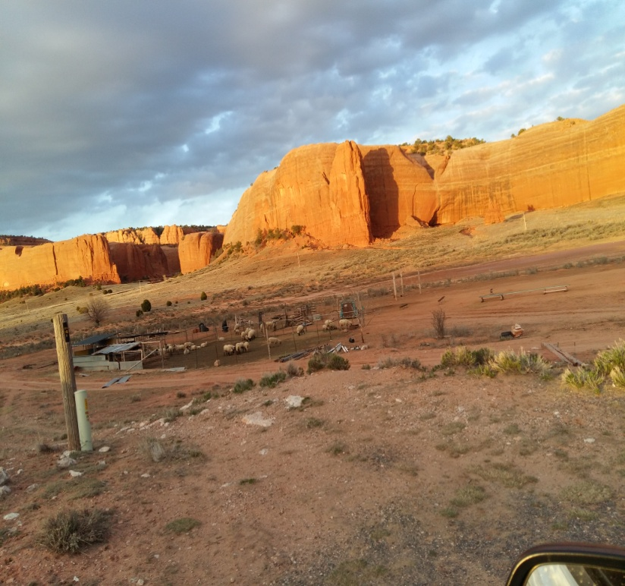](http://www.google.com/url?sa=i&rct=j&q=&esrc=s&source=images&cd=&cad=rja&uact=8&ved=0ahUKEwiflqauqL7VAhUpxlQKHRowBMsQjRwIBw&url=http://www.supercoloring.com/coloring-pages/vitruvian-man-by-leonardo-da-vinci&psig=AFQjCNGmh-S8RLr808HqU1B21TKkhTgS1A&ust=1501960759630103)

Grade Level**:** 9th and 10th

Required Knowledge base**:**

Students should be able to read and provide a written response to the science reading topics. Students should be able to write an appropriate sentence, paragraph, and various types of reports. Students should be able to know and use appropriate mathematics skills to show their ability to describe and explain lab results. Students should be able to use their reading, writing, and math skills to demonstrate knowledge of the topics under study.

Recommended Lab knowledge base**:**

This course may provide ample laboratory experience (microscopes, balance, and pipettes) that applies to the study of cells, tissues, organs, and organ systems.

**Window Rock High School Biology topics:**

*Unit Description* Semester One

1. Matter and Energy in Organisms
2. Homeostasis and Cell Function in Organisms
3. Growth, Development, and Reproduction in Organisms

*Unit Description* Semester Two

1. Matter and Energy in Ecosystems
2. Ecosystems and Populations
3. Natural Selection
4. Inheritable Traits

**Textbook:** Biology by Pearson Prentice Hall, authors Miller and Levine (2006)

**Laboratory Manual A**: Biology by Pearson Prentice Hall, authors Miller and Levine (2006)

**Reading and Study Workbook A**: Biology by Pearson Prentice Hall, authors Miller and Levine (2006)

**Required Student Materials and skills:**

* Three-ring binder with dividers and/or Composition book for Portfolio.
* Computer with internet access
* Computer skills to download and transmit virtual assignments.
* Paper; ruled and graph
* Blue and/or black ink pens (other colored ink will not be allowed)
* Pencils and Colored pencils

**Portfolio**– Students will organize all their Earth Science class assignments, tests/quizzes, and science writing assignments. The Portfolio needs to be presented in a folder or binder. Students will create a summary in the front of the portfolio that will display the student’s scores and comments for each assignment category and will date and sign. We will work together during the process and will analyze the portfolios monthly. Complete portfolios are due during Finals week. Students will also include two assignment artifacts from each category (six total) that they will designate as an example of their “best” work and another as their “delta” or not-so-best work. Students will write a half page minimum analysis and critique on why they chose their artifacts. The artifacts must be included with this written assignment.

**Grading will be the following scale for each assessment category:**

1. Summative Assessments (**40%**):  performance–based individual and group participation, and science writing activities (reports and APA research paper. These assessments will be graded during each unit, chapter, and quarter.
2. Formative (learning) Assessments (**20%**): Unit quizzes, quarter tests, semester exams, and project – based learning projects.
3. Class Work/Homework (**20%**): Science math, worksheets, vocabulary activities, class Cornell notes, unit and quiz SOAR graphic organizers, and continuous improvement activities.
4. Projects (**20%**): laboratory experiments, observation mini-labs, science fair

**Class Expectations**

1. Students should be in seats when the bell rings. The school’s tardy policy will be enforced.
2. Late work for other than absences will not be accepted. Work is due when the teacher designates a deadline or, at a maximum, of two weeks after it is assigned, if the teacher does not announce a deadline.
3. If a student is absent:
   1. It is the student’s responsibility to obtain make up work from the teacher.
   2. Any material due the day of the absence is due the day of return.
   3. If a test or quiz has been announced it will be taken the day of the test if you are absent only the day before.
   4. Make up tests will cover the same material but will not necessarily be in the same format as the original test.
4. Any work missed due to an absence MUST BE MADE UP BY AND TURNED IN BY THURSDAY OF THE FOLLOWING WEEK!!
5. Disruptive behavior of any type will not be tolerated. Do not engage in behavior that will annoy or distract anyone in the classroom.
6. All school rules, policies, and procedures listed in the Student Handbook are also in effect in the classroom.

**Teacher Contact Information**

I am more than willing to help you be successful in this class. I am willing to give you individual help at the following times listed below. Please come and talk to me if you are having trouble.

1. Mondays through Thursdays after school from 3:30 to 5:00 pm in room C18.
2. My planning period is during the 5th period. This is the best time for parent phone calls.
3. Tutoring times can be scheduled, if required by student, parents, or teacher.
4. Please feel free to email me at [**www.mbarton@wrschool.net**](http://www.mbarton@wrschool.net) or call me at school (at 928-7055, the secretary will contact me or leave a message with me), and I will return your call as soon as possible.

Student:

1. I have read the syllabus and understand its content.
2. I understand that there will be Biology assignments requiring an email address (such as login onto an Canvas account to take a quiz or download handouts from the Teacher’s Google Drive account) and will give the teacher a contact email address for these Biology class assignments.

_____________________________ _____________________________ ________________

*Student Name Signature Date*

Student’s email __________________________________________

1. Not all students will be given a textbook because of the limited number of available textbooks. A Virtual textbook will be made available through Google Drive for all students.

Parents:

1. I have read the syllabus and understand its contents.
2. I also understand that if the teacher wants to contact the parent, I will provide my contact information.

_______________________________ _________________________________ ________________

Parent name Signature Date

Parent’s email __________________________________________

Parent phone or cell number during school hours: ______________________________

Parents, please use the space below, and if necessary the back of this sheet, for any comments on the syllabus or any other concerns that are important for me to know and understand. Thank you.